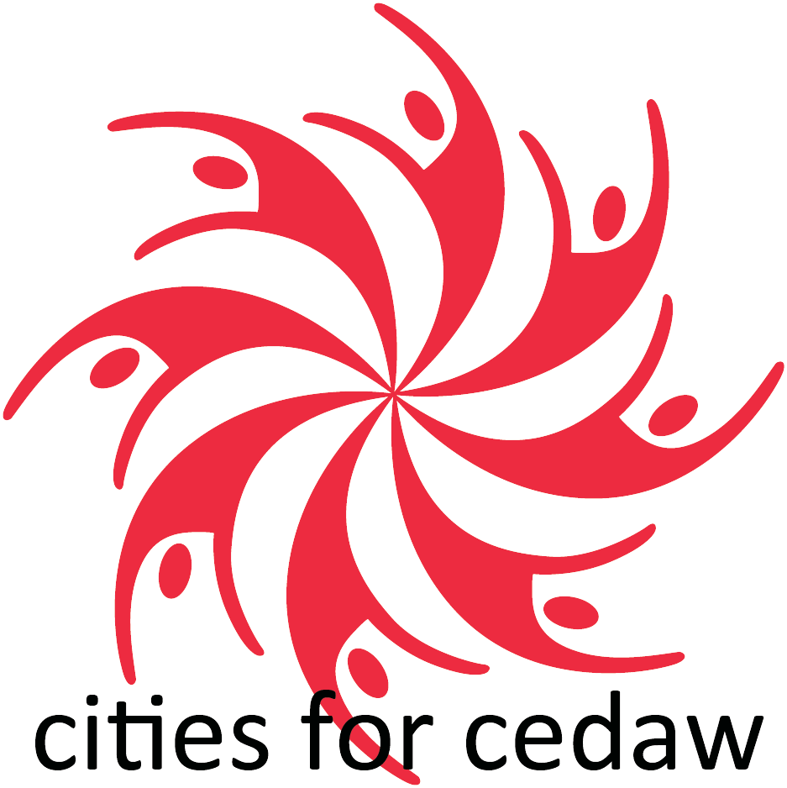
Beijing + 30

[DATE]

Dear [MAYOR and CITY COUNCIL MEMBERS/COUNTY SUPERVISORS/STATE OFFICIALS]

On behalf of [NAME OF NGO or GROUP], we wish to congratulate you on the historic passage of the CEDAW [ORDINANCE/RESOLUTION] in [LOCALITY] which was accomplished (DATE). This was achieved through the efforts of local coalitions, working hand in hand with local government officials.

As a City for CEDAW, [LOCALITY] is part of a grassroots, decades-long movement to protect women’s rights. Other cities include Pittsburgh, San Francisco, Salt Lake City, Los Angeles, and Washington DC. Miami-Dade County and Hawaii led the way for more than 12 other counties to put CEDAW on the map. You deserve to be recognized because [LOCALITY] is in the company of more than 65 other jurisdictions across the country, covering more than 82 million US citizens.

In 2025, the Cities for CEDAW History and Futures Project will showcase (y)our achievements at the United Nations during the Commission on the Status of Women celebration of Beijing + 30 in New York.

We call on you to take action to implement (y)our CEDAW [ORDINANCE/RESOLUTION].

[LIST OF ACTIONS] Add your demands for action here. Some ideas:

(1) update a gender analysis/study
(2) ensure funding for CEDAW youth initiatives
(3) improve data in gender budgeting
(4) pass a CEDAW ordinance (if your city, county or state has a resolution)

As we face setbacks on women’s rights, now is the time to scale up our efforts locally to protect and expand rights at the local level.

We thank you for your dedication to making rights real for the people of [LOCALITY].

Sincerely,

[NAME OF SIGNATORIES/ORGANIZATION/WRITER]

